Данча

Тема 16

**Перший рівень**

1. <https://automoto.ua/uk/>

| № | Summary | Preconditions | Steps | Expected result | Priority |
| --- | --- | --- | --- | --- | --- |
| 1. | Check valid phone number for registration in “Мої оголошення” | Have a valid phone number 380506578345 | 1. Go to <https://automoto.ua/uk/>  2. Click on registration icon  3. Enter valid phone number from preconditions  4. Click button “Продовжити” | New page with registration form should open | 1 (High) |
| 2. | Check selection in dropdown list “Всі типи транспорту”  [Легкові] |  | 1. Go to <https://automoto.ua/uk/>  2. Click dropdown list “Всі типи транспорту”  3. Choose “Легкові” | User`s choice should appear in the dropdown list | 2 (Medium) |
| 3. | Check enter numbers in input field “Ціна до” |  | 1. Go to <https://automoto.ua/uk/>  2. Enter numbers in input field “Ціна до” | Numbers should appear in input field “Ціна до” | 1 (High) |
| 4. | Check button “Поиск” without enter data |  | 1. Go to <https://automoto.ua/uk/>  2. Click on button “Поиск” | New window with catalog should open | 2 (Medium) |
| 5. | Check opening an ad from the catalog | Catalog should have an ad | 1. Go to <https://automoto.ua/uk/>  2. Scroll down to an ad  3. Click to an ad | New window with detail information about an ad should open | 1 (High) |

1. <https://reqbin.com/>

* LIST USERS

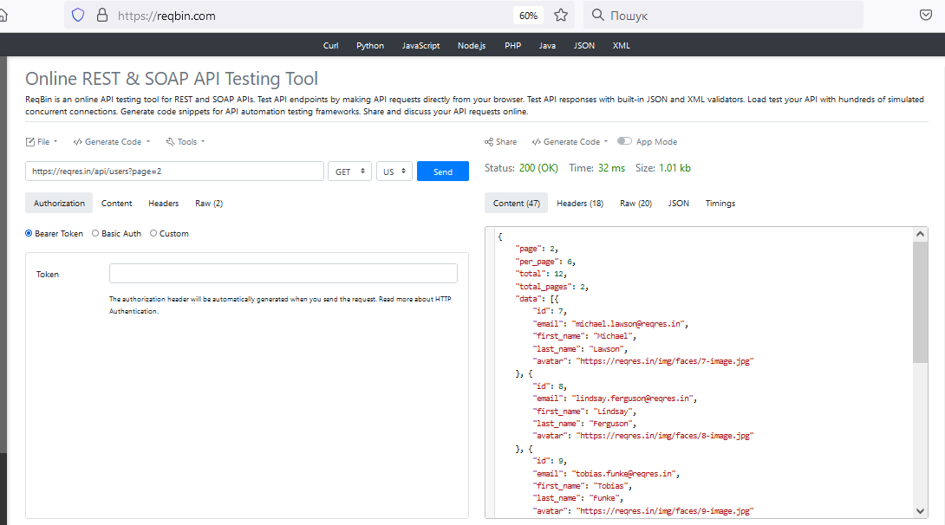

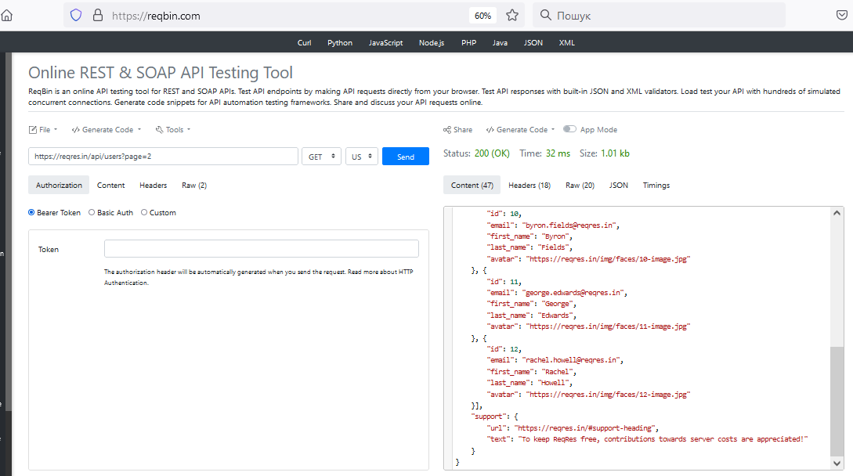

* SINGLE USER

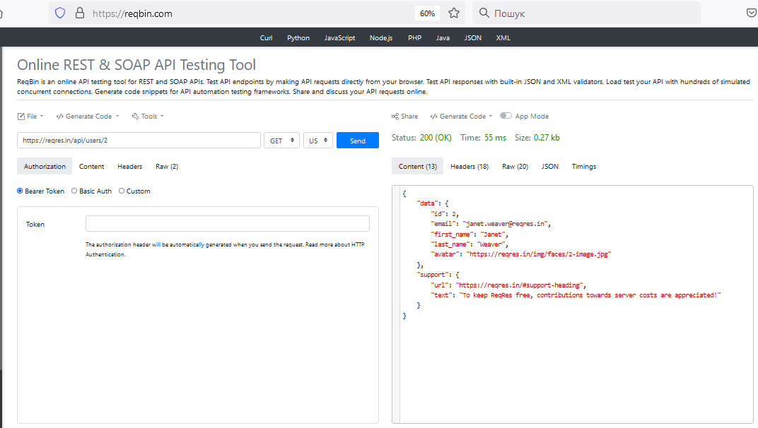

* CREATE

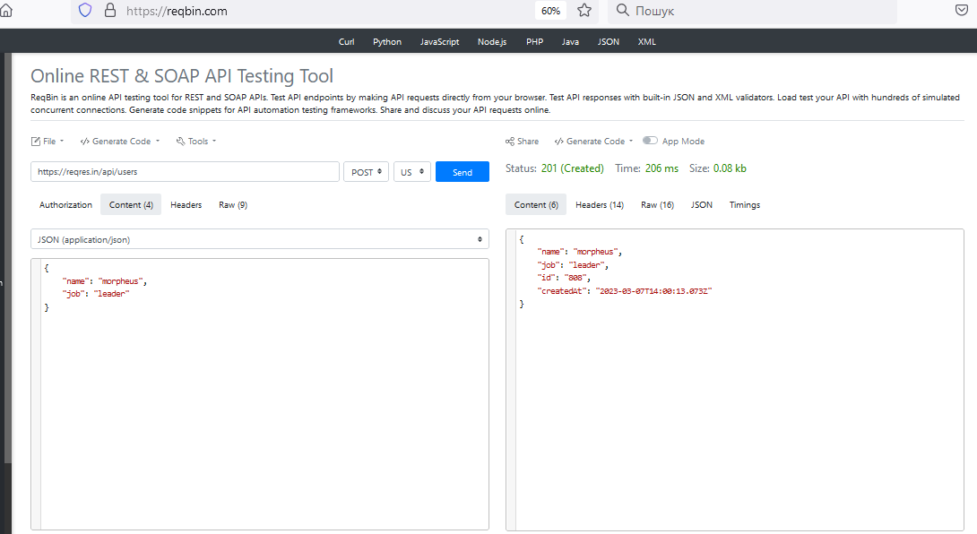

* UPDATE (PUT)

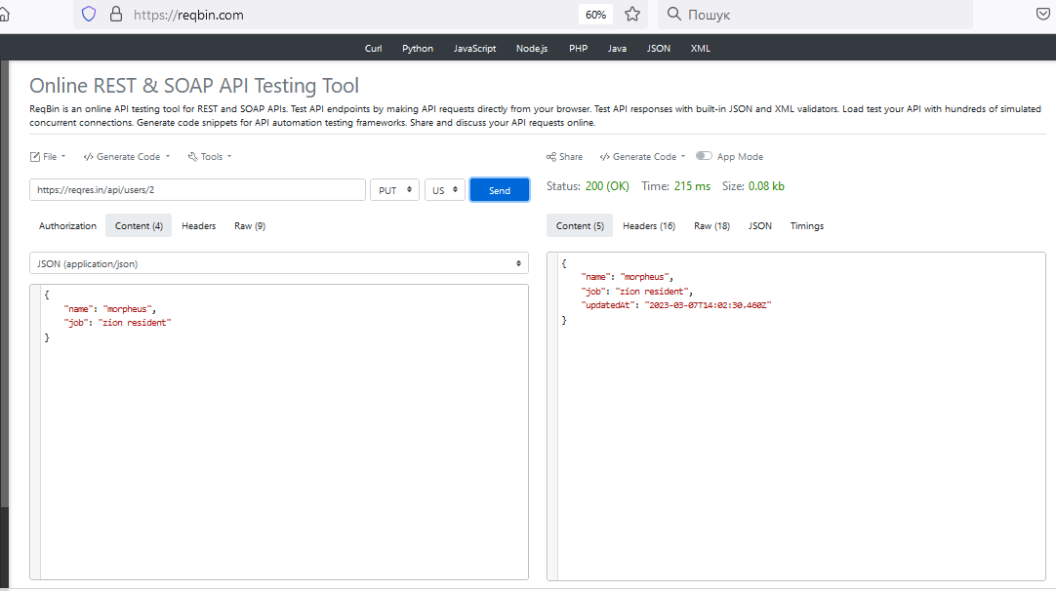

* UPDATE (PATCH)

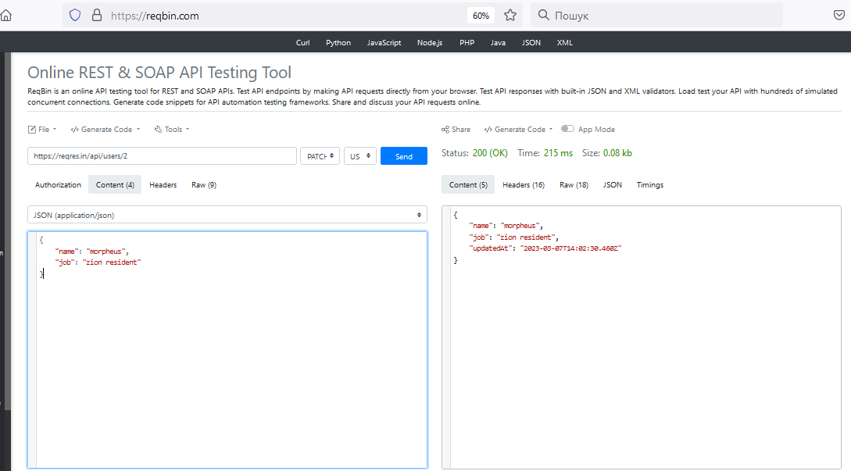

* DELETE

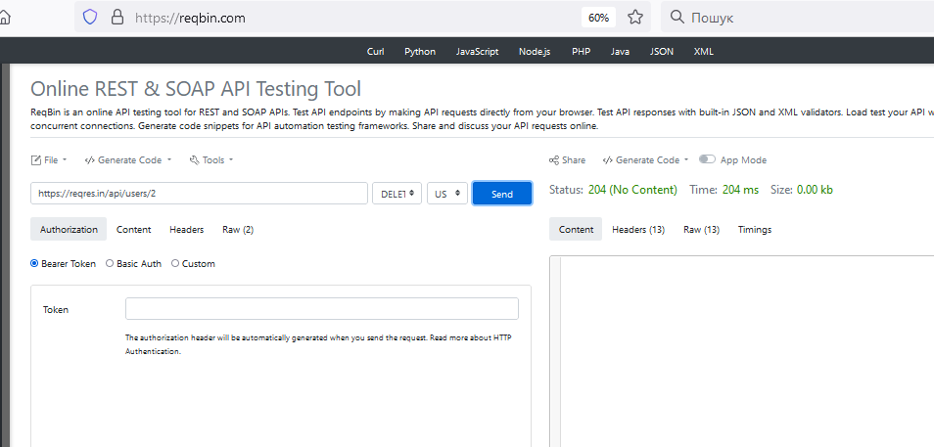

* REGISTER - SUCCESSFUL

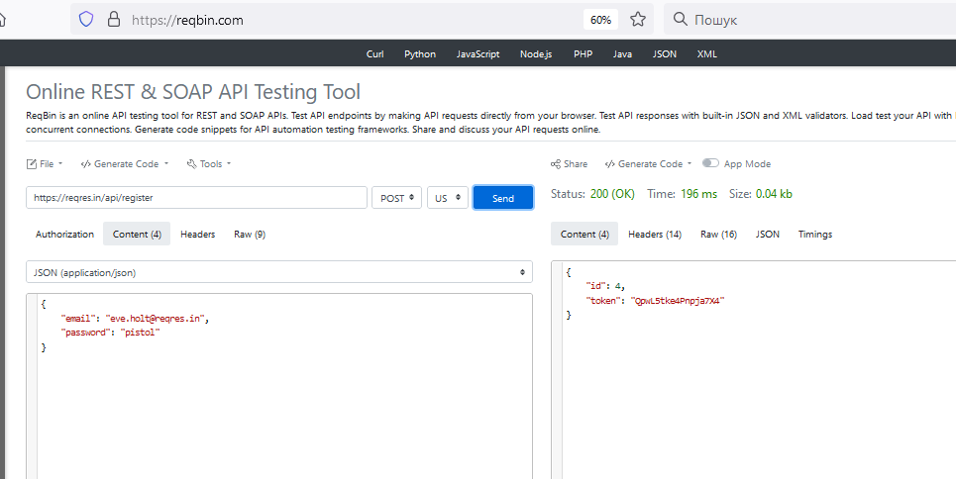

* LOGIN - SUCCESSFUL

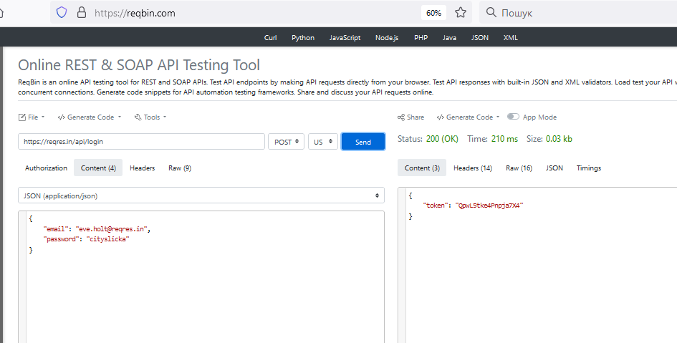

**Другий та третій рівні**

<https://gorest.co.in/>

* POST Create a new user

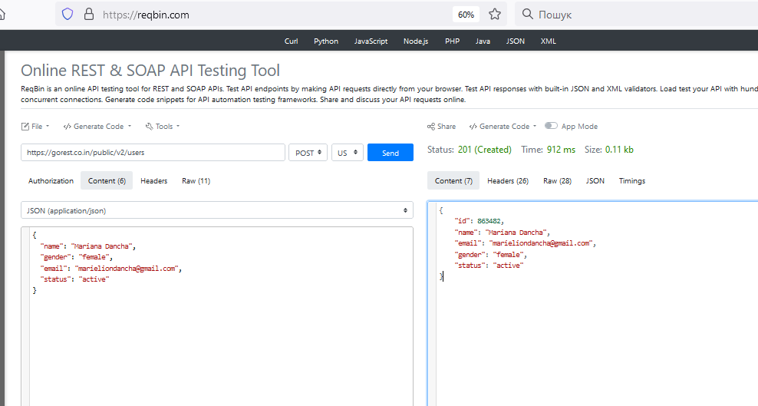

* GET Get user details

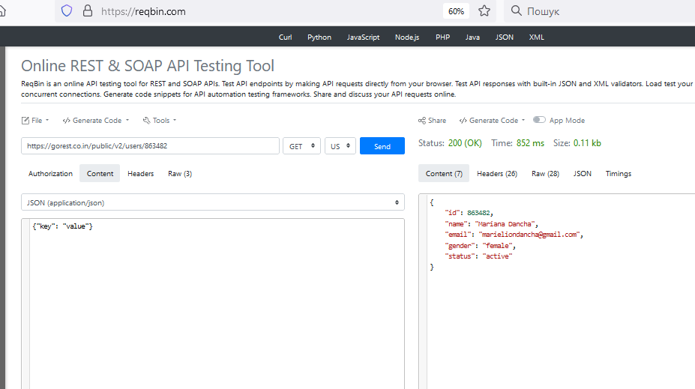

* PUT Update user details

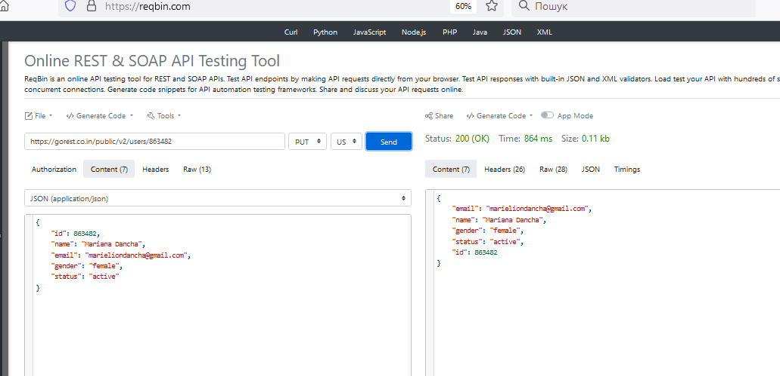

* DELETE Delete user

